**One Minute Activities**

1. Flip the Cup

* The Cup needs to be flipped and if cup lands properly on the ground in bottom down ways the cup is counted. Whoever flips highest Number of Cups in One Minute Correctly Wins.
* Winner (Rudra Brahmbhatt and Saiyam Sanghvi)

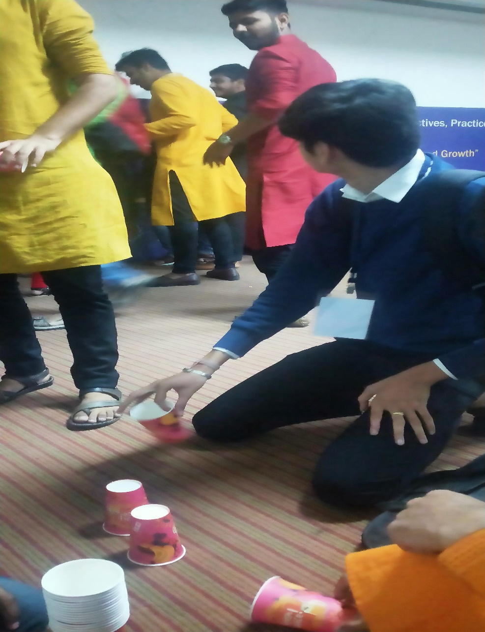

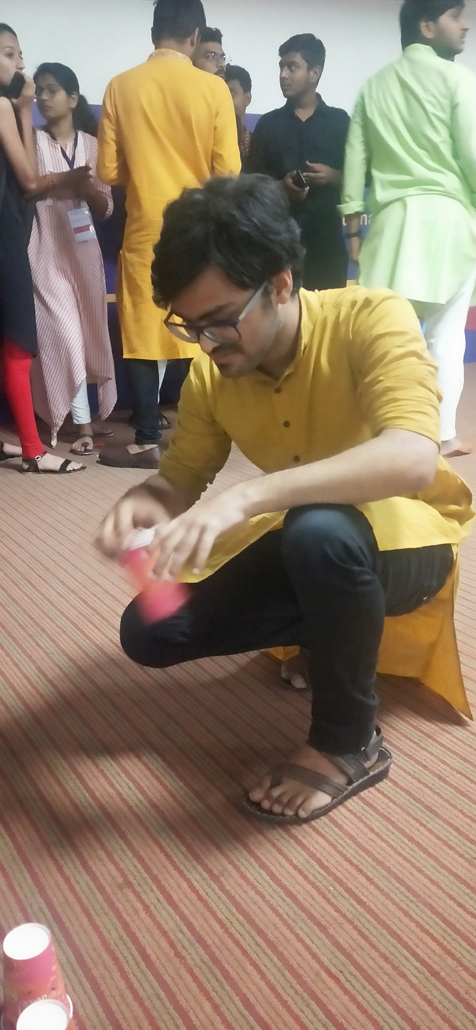

1. Pop the Balloon (Khushi Prajapati and Ishita)

* Initially time period of one Minute was given and the teams who pops the maximum balloon in that period wins. And in Final Round 7 Balloons were given and the team who popped all the balloons first Won.
* Winner (Harsh Sevani and Sunny pal)

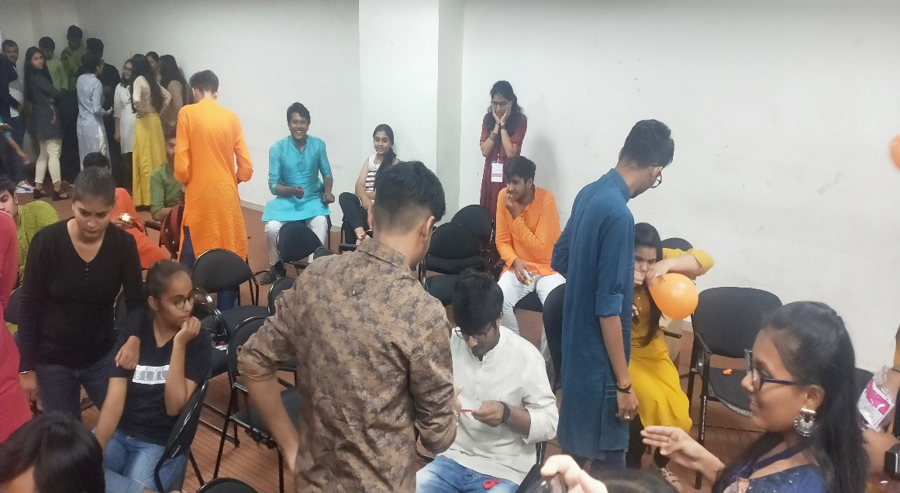

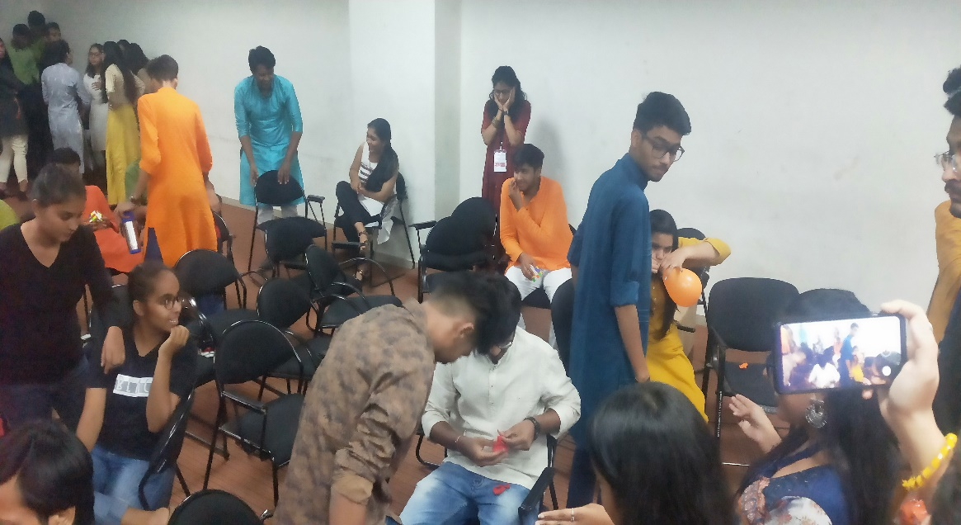

1. Straw and Ball

* Here there were two cups in one cup there were thermocol balls and from that cup one need to suck the ball with straw and keep them in another Cup. The One who transferred maximum balls in one minute was the Winner.
* Winners (Dev Patel and Harsh Dhruv)

